Harnessing Energy

**Module Goal:** To introduce the concepts of capturing energy in one form and converting it into other forms. The target audience is students aged 10-13.

**Module Content**: This textbook and 5 supplemental videos.

**Learning Objectives:** Students learn the concept of power conversion and use it to analyze the operational principles of a motor, generator, and solar panel.

**Teaching time**: Four 1-hour periods.

**Special Instructions:** Students should read the text prior to the class. Conceptual review questions may be assigned as homework or in-class work. For each demo, instructors need to review the instructions and gather the necessary supplies in advance. Whenever possible, instructors should prepare the demos before class as practice. Students can be grouped into teams of 2-4 for the activities.

Harnessing Energy was prepared by: Sanyogita Purandare, Shibin Qin, Sairaj Vijaykumar, Professor Alejandro Dominguez-Garcia, Professor Robert Pilawa, and Professor Lynford L. Goddard

University of Illinois at Urbana Champaign

Department of Electrical and Computer Engineering

1406 West Green Street

Urbana, IL 61801 USA

October 10, 2012

\\ad.uiuc.edu\MNTL\lgoddard\desktop\Proposals\PowerElectronicsCamp\Deliverables\CC-BY-NC-SA.png

This work, which includes the textbook and videos, is licensed under a Creative Commons Attribution-Noncommercial-Share Alike 3.0 Unported License. To view a copy of this license, visit: <http://creativecommons.org/licenses/by-nc-sa/3.0/>. To attribute this work, please write: S. Purandare, S. Qin, S. Vijaykumar, A. Dominguez-Garcia, R. Pilawa, and L. L. Goddard, Harnessing Energy (2012).

**Class #1: What is Energy?**

We use energy for everything we do. We get energy from the food we eat and we use it to walk, run, play and work. We need energy to move a table. So, **energy is the ability to do work.**

There are many different forms of energy. For example: electrical energy, mechanical energy, solar energy. Let us review some concepts about electrical energy.

**What is electrical energy?**

Everything is made up of tiny particles called atoms. Atoms are made up of a center called a nucleus which is positively charged and tiny particles called electrons which are negatively charged. The nucleus is heavy and difficult to move. Electrons are small and light, and move about easily. **Electricity is the form of energy that is due to the movement of electrons.** Let us understand this from the example of a light bulb.

Below is a close-up picture of an outlet, switch, wire and bulb. The wire is made up of atoms.

1a

1b

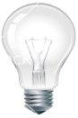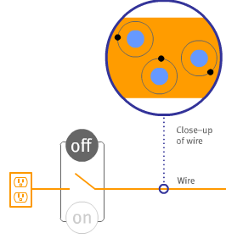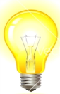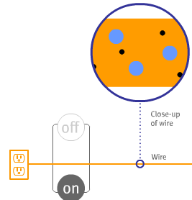

Figure 1a. Switch is off. Each electron (black dot) is bound to the nucleus (larger blue dot) in an atom and does not move. Figure 1b. Switch is on. Electrons (black dots) are free from the nuclei (larger blue dots) and can move in the wire.

When we turn the switch on, the electrons in these atoms start moving. A moving electron pushes on the electron ahead of it just like how marbles collide with one another and move forward in a tube.

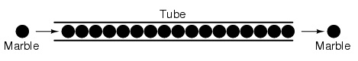

The bulb itself has a very narrow wire or tube that restricts the flow of electrons. So, electrons cannot move as easily through the narrow bulb wire as they can through the regular wire. **This restriction of flow is called resistance.** **The unit of measure for resistance is called Ohms ().** When electrons try to move in the narrow bulb wire, they generate heat and the bulb lights up.

**Conceptual Review Questions**

1. In figure 1, what provides energy to the electrons to free them from the nucleus and allow them to move in a wire?
2. Can you think of another source of electrical energy?
3. Besides light bulbs, where else do we use electrical energy in our everyday lives?
4. What are some examples where we capture energy in one form and convert it into another form?

**Possible Answers**

1. The electrical outlet (110V) provides electrical energy to the electrons.
2. Other sources of electrical energy include batteries, which convert chemical energy to electrical energy and solar panels, which convert sunlight into electrical energy.
3. Many devices in our home use electrical energy including our refrigerator, TV, microwave oven, and computer.
4. When we turn the light switch on, we get electrical energy from the outlet and convert it into heat energy and light energy in the narrow wire of the light bulb. We get chemical energy from the food we eat, store it in our body, and convert it in kinetic energy when we walk or run.

**Project #1 - Building an electromagnet**

**Objective:** To understand how moving charge can create an electromagnet.

**What is a magnetic field?**

When we bring a magnet close to small pins of iron, the pins gets stuck onto the magnet. **A magnetic field is a description of this magnetic influence which attracts the iron pins towards the magnet.** The magnetic field can be produced by a magnetic material or by an electric current.

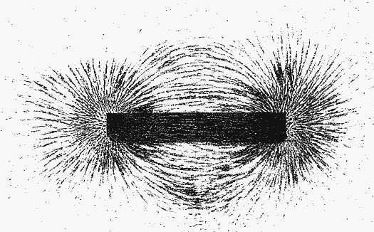

Figure 2 Magnetic field

**What is an electrical current?**

**An electrical current is the flow of electrons around a circuit.** When electrons move, we have a current. **An ammeter is an instrument that measures current. The unit of measure for current is called Amps (A). One amp is a lot of current and so we usually see milli-Amps (mA), which are thousandths of an Amp.** Electrical current, voltage, and resistance are the three key electrical parameters that help us to understand how a circuit works. **A multimeter is an instrument that can measure electrical current, voltage, and resistance.** See **video #1** on how to use the multimeter.

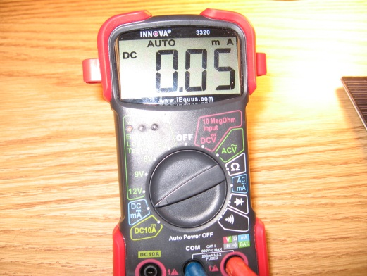

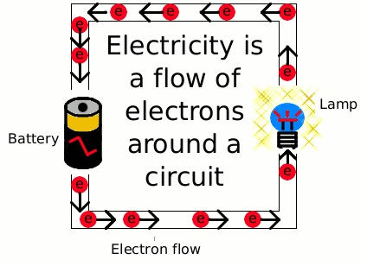

Current is

Figure 3 Electrical current flowing in a circuit Figure 4 A digital multimeter set to measure current

**What is voltage?**

Common everyday batteries such as AAA, AA, or 9V supply electrical energy. **Voltage describes the amount of energy available to do work.** Imagine a car at the top of a hill. The voltage describes the height of the hill. The higher the voltage, the more kinetic energy you will have when you reach the bottom of the hill. **The unit of measure for voltage is called Volts (V).** A single AA battery supplies 1.5 volts, whereas our electrical outlets supply 110 volts and thus can give each electron moving in the circuit over 73 times as much energy as the AA battery.

**What is an electromagnet?**

**An electromagnet is a magnet which is made by flowing current in a wire.** It is different from a permanent magnet, which always creates a magnetic field. Both types of magnets will attract iron pins. But, electromagnets are magnets only when we flow current through the wire.

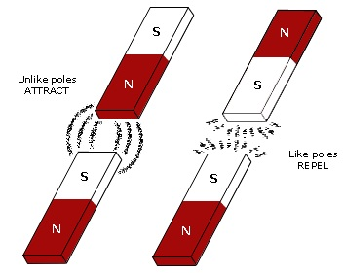

Figure 5 A permanent bar magnet made out of a material, such as metal, that has been magnetized

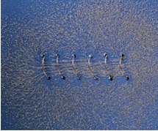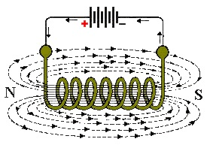

Figure 6 An electromagnet formed by flowing current; iron filings line up in the direction of the magnetic field

With an electromagnet, the north and south poles are determined by the direction of the current flow. If we look along the axis of the wire loop and the current is circling counterclockwise, then we are looking at the north pole of the electromagnet. If the current is circling clockwise, then we are looking at the south pole of the electromagnet.



Figure 7 An electromagnet with the relationship between the direction of its current and its magnetic poles

**Demonstration of an electromagnet**

**Parts needed per team:**

1. Magnetic compass (suggested: Coleman Map - Model No. 2000007838)
2. AA Battery 1.5 V (optional: battery clip)
3. Wire (suggested: a 50Ft spool or a 100Ft spool of UL-Recognized Hookup Wire 26-30 AWG such as Radio Shack 278-502)
4. Optional: 3 alligator clips (suggested: Radio Shack 270-346, which is a pack of 8 clips)

**Project setup (see video #2)**

1. The needle position of the compass, which is shown below before building our electromagnet, points to Earth’s magnetic north.

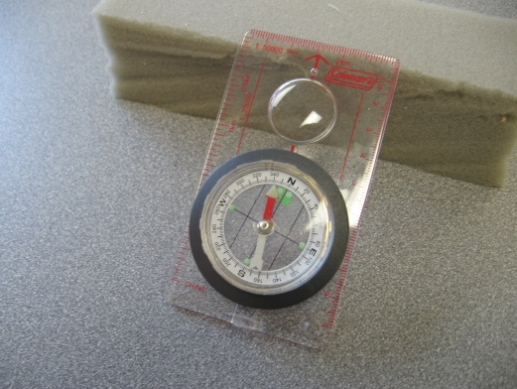

1. Now we will bring a permanent magnet close to the compass to observe the change in the local magnetic field due to the permanent magnet. The needle position moves from the earlier position and shows both poles of the permanent magnet in the images below.

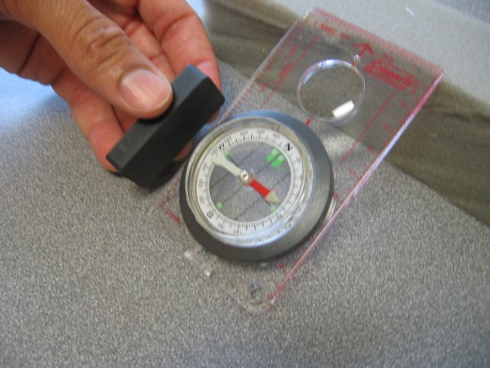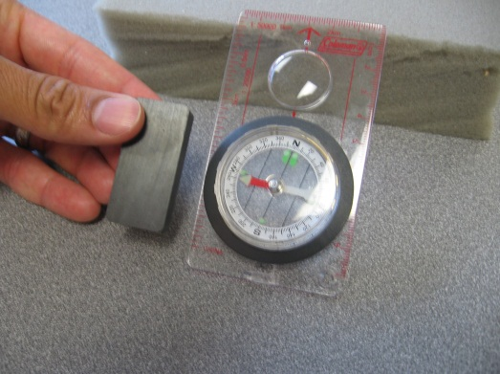

1. We will now measure the resistance of our spool of thin black wire. We observed a resistance of 4 Ohms for approximately 100ft of 26AWG wire. Higher AWG numbers correspond to thinner wires and thus higher resistances for a given length.

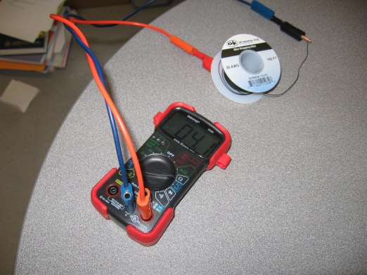

1. We would like the spool to have a resistance between 1-10 Ohms. If your measured resistance is too low, you can connect 2 spools together in series. If your resistance is too high, you can connect 2 spools together in parallel. **A series connection has each circuit element connected one after the other, like links in a chain.** Thus, to make a series connection between 2 spools, connect one end of spool #1 to one end of spool #2 and measure the resistance between the loose ends of spool #1 and #2. The optional alligator clips can be used to hold the wires together. Tape can be used instead of the clips, but be sure the wires are well twisted together. **In a parallel connection, the left sides of all elements are connected together and the right sides of all elements are connected together.** We will discuss series and parallel in more detail in class #4.
2. We are now ready to build our electromagnet. Connect a single AA battery to the wire spool. The resistance of our wire spool will allow us to drive a controlled amount of current from the AA battery through the wire. Controlling the current is important because it prevents the wire and battery from heating up too much and burning our hands and draining the battery too quickly. **Warning: without the resistance of the long wire spool, the battery can become very hot and will be drained very quickly.** Bring the spool close to the compass and observe the change in the needle position. Does the needle move in a direction that agrees with Figure 7? Look closely at the direction that the spool is wound up.

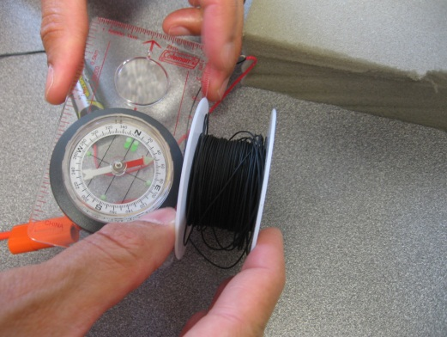

1. Try moving the compass to the other side of the electromagnet and observe the change in the needle position. Did it reverse?

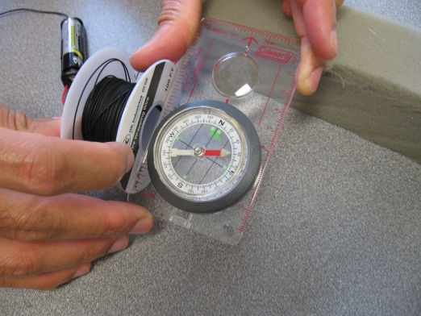

1. When current flows in the wire, it becomes an electromagnet. So, disconnect the wire from the battery and see whether the compass needle returns to its original position. The wire is no longer an electromagnet because there is no current flowing in it.
2. Time permitting, you can try using a wire spool of the same length but with a higher resistance. You should observe that the strength of the electromagnet gets weaker since the strength depends on the amount of current flowing in the wire. There is an important relationship between voltage, current, and resistance. **Ohm’s law states that the current flowing in the wire is equal to the voltage of the battery divided by the resistance of the wire.** In video #2, we measured the voltage of the battery to be 1.3V, the resistance of the wire to be 4.2 Ohms, and the current flowing through 0.3 A. These numbers are approximately consistent with Ohm’s law. The slight discrepancy could be due to small amounts of additional resistance in the circuit connections that were not measured.

**Conceptual Review Questions**

1. Can you easily increase the strength of a permanent magnet?
2. Can you easily increase the strength of an electromagnet?
3. How can you identify the magnetic poles of an electromagnet?
4. Can you name few applications of an electromagnet?

**Possible Answers**

1. The strength of a permanent magnet cannot be increased easily. You would have to change the magnet’s size, geometry, or material composition to increase its strength.
2. We can easily increase the strength of an electromagnet in several ways:
   1. By increasing the current flowing in the wire. The current can be increased either by using a higher voltage battery (e.g. 9V versus 1.5V) or by using thicker wire to reduce the resistance or by doing both. But, be careful, the wire and battery can become very hot in the process.
   2. By using more turns of wire. It is like putting several electromagnets next to each other.
   3. By putting in a soft iron core. The soft iron becomes a magnet in the presence of an electromagnet and it increases the strength of the electromagnet.
3. The north pole of an electromagnet is the side that the current flows counterclockwise when you towards the loop. The south pole is the side that the current flows clockwise.
4. An electromagnet is used for making motors that run machines, and for making generators to create electricity. There are several other applications of the electromagnets listed at the website: <http://en.wikipedia.org/wiki/Electromagnet#Uses_of_electromagnets>

**Class #2 - Motors**

**Can we spin an electromagnet by moving a permanent magnet near to it?**

Yes. When we bring a magnet near an electromagnet, the invisible magnetic force acts upon the electromagnet. We saw previously that an electromagnet has a north and a south pole just like a permanent magnet. There is an attractive force between opposite poles of two magnets that tries to bring the two magnets together. So, the opposite poles of an electromagnet and a permanent magnet attract each other. There is repulsion between the like poles of the electromagnet and permanent magnet and the invisible force tries to push the like poles away from each other. If the electromagnet is free to spin and we move a permanent magnet towards the electromagnet then this force will cause the electromagnet to rotate. We will make a tiny motor using these concepts.

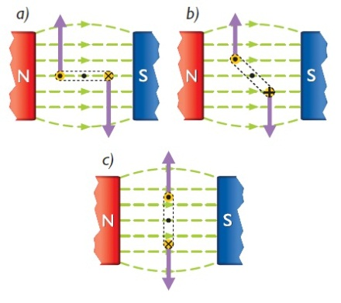

Figure 8 An electromagnet rotating due to the magnetic field of two permanent magnets

**What is a motor?**

Our body transforms chemical energy from food into kinetic energy when we walk, run or play. **A motor is a device that transforms electrical energy into mechanical energy.** We will use the attraction and repulsion properties of magnets and electromagnets to create a motor.

**Project #2 - Using a magnet to rotate a motor**

**Objective:** To understand how motors work. More specifically, to see how a magnetic field can rotate an electromagnet.

**Special Instructions:** The instructor may want to prepare this setup in advance and allow students to explore the results. This project uses inexpensive items to demonstrate how a motor works and the energy conversions during operation. Time permitting, each team can prepare its own motor loop and stand.

**Parts needed for the class:**

* 1. cardboard
  2. tape
  3. magnet (1x2x5cm [ceramic](http://amasci.com/coilgen/rsmagnet.html) magnet: [Radio Shack #64-1877](http://www.radioshack.com/product/index.jsp?productId=2102689))
  4. #30 Magnet wire 15ft, [Radio Shack 278-1345 is 315 feet in assorted colors](http://www.radioshack.com/product/index.jsp?productId=2036277)
  5. 2 large paper clips
  6. One 1.5 V battery and corresponding battery holder (AA, C, or D are OK, Radio Shack #270-401 holds a “AA” cell, #270-402 holds a "C" cell, #270-403 holds a "D" cell)
  7. Digital multimeter (suggested: Equus 3320 Auto-Ranging Digital Multimeter)
  8. Optional: Alligator clips (suggested: Radio Shack 270-346)

**Project setup (see video #3)**

1. Get two large paper clips and straighten the longer bent part and make a small loop out of it. Make the clips stand on the smaller bent portion.

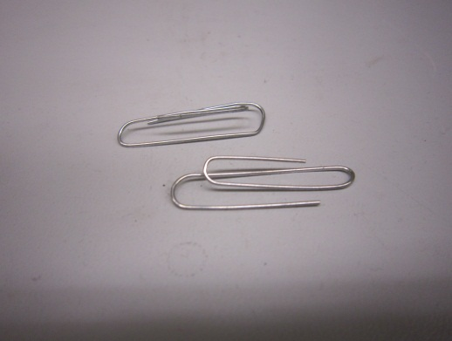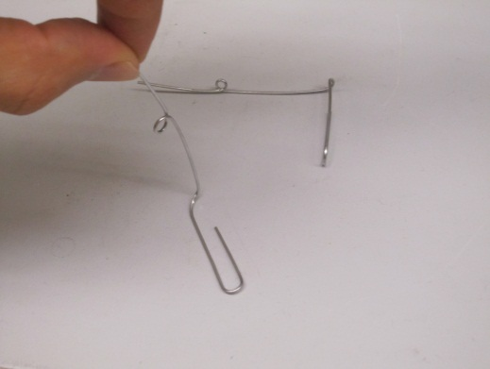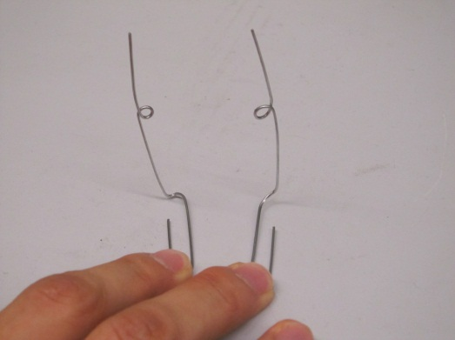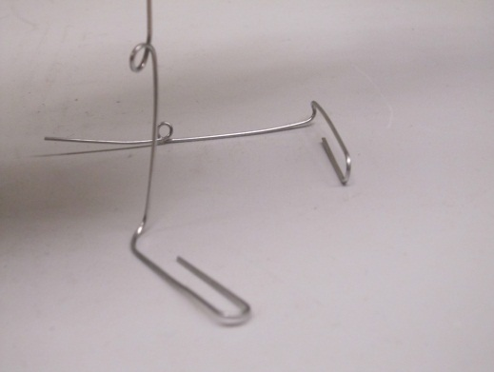

1. You will take the magnet wire and create a small loop with many windings by wrapping the wire around a pen. This winding step is crucial for the success of the project. We need to use a pen with a cylinder shaped body so that the loop doesn’t get distorted when we remove it by sliding it off of the pen. A wide body pen will work better. The total length of wire used should be about 15 feet, which corresponds to about 150 windings with a wide body pen or 210 windings with a normal body pen. Now take the two loose ends of the loop and tie it around the loop.

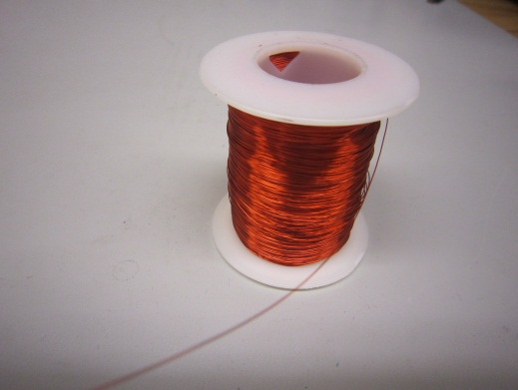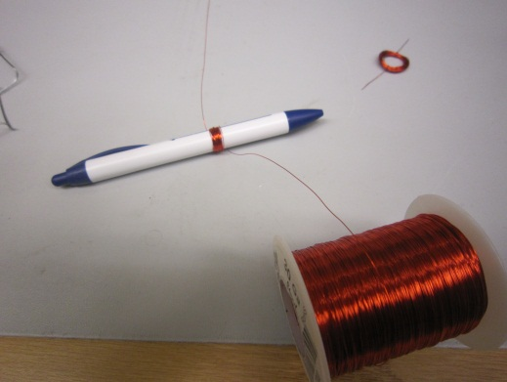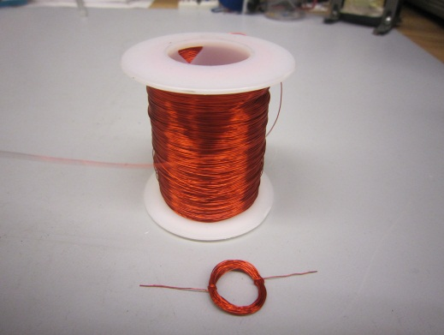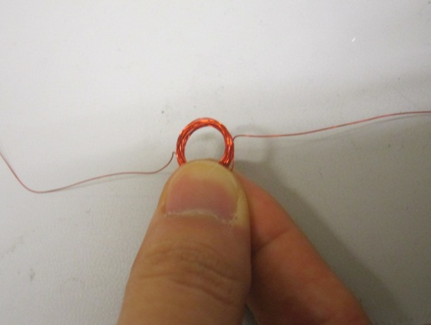

1. Students should ask the instructor for help on this step. On each loose end of the loop, remove the top half of bright red insulation cover as shown in the picture below. This will expose the wire hidden behind the red cover. This step needs to be done carefully. The amount exposed needs to be very close to 50% of the circumference. The loop should be sturdy and not get distorted when the students play with it. We remove only the top half of the wire cover so that when the red loop rotates, there will be a period of time when current can flow through the loop and create an electromagnet and also a period of time when no current flows and the electromagnet is turned off. We want the loop to rotate in one direction continuously. When the loop rotates and the bare wire is rotated to face down, it will be touching the wire supports, and current will flow to the coil, creating an electromagnet with magnetic poles that can be pushed or pulled by a permanent magnet causing the loop to begin to rotate. When the bare wire is rotated up, the insulated wire cover will be touching the wire supports, and no current will flow to the coil. This allows the loop to continue rotating in the same direction. If the current were to flow in the coil at all times, the magnet would cause the loop to rotate back and forth instead of making complete rotations.



1. Examine the paper clips prepared in step 1. It is important that: (1) the lengths of the paper clips are equal, (2) the paper clips are standing straight up and not bent, and (3) the loop size of the two clips are approximately equal. Now tape the paper clips to the cardboard.

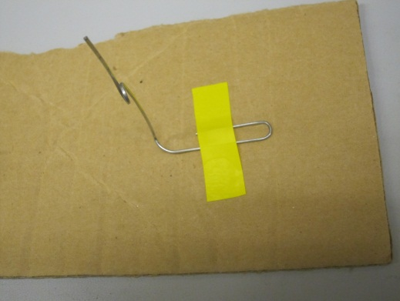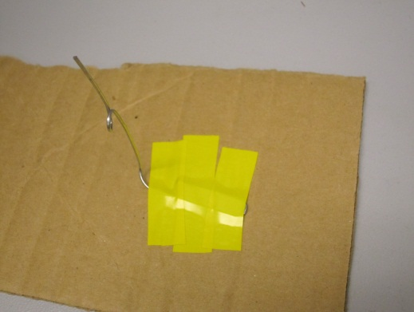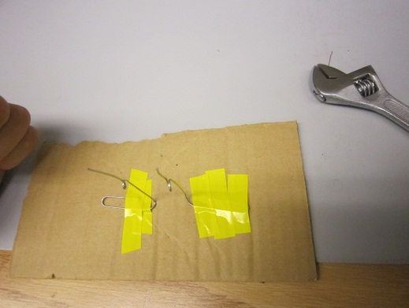

1. Now carefully hang the loose ends of the loop of magnet wire in the loops of the paper clips.

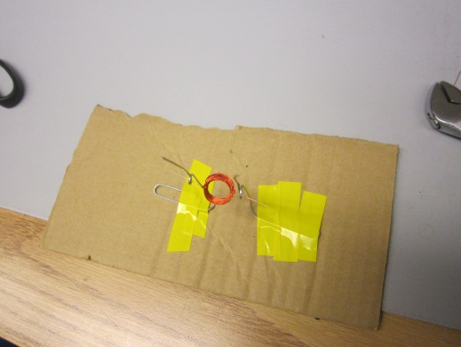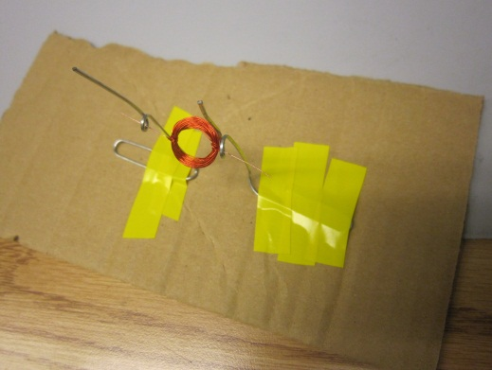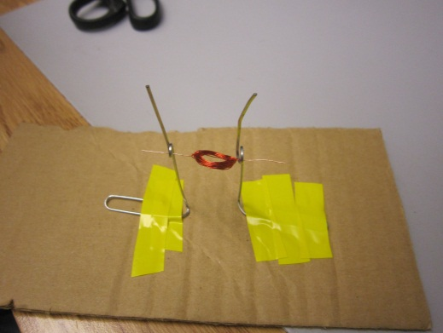

1. Using the multimeter, measure the resistance between the two clips when the bare wire is in contact with the clips and also when the insulated wire is in contact. The values should be approximately 1.5 Ohms and O.L., which stands for overload and means that the resistance is higher than what the multimeter can measure.
2. Now connect the paper clips to a single 1.5 V battery to make current flow up one paper clip, through the multiple winding loops of wire, and back down the other paper clip before returning to the battery. The optional alligator clips are helpful for holding the circuit parts together on this step. **Caution: with a 1.5 V source and only 1.5 Ohms of resistance, there will be approximately 1 A of current. The AA battery will drain in about 1 hour. C and D batteries will last a few hours. Also, with 1 A of current, the battery might become hot. Do not leave the setup unattended.**

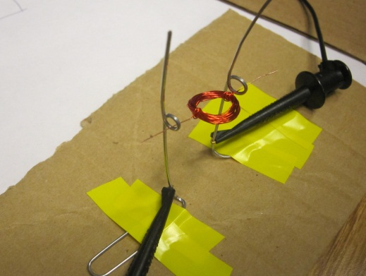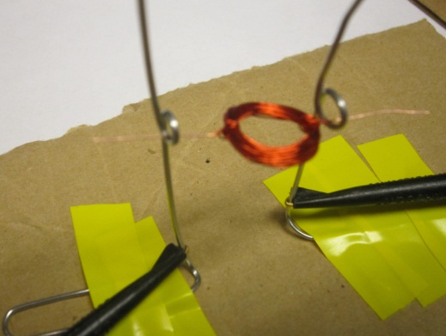

1. Now take a permanent magnet and try moving it close to the red loop. The loop will start rotating on its own. If it doesn’t, give it a slight nudge to start it. It should then be able to spin on its own.

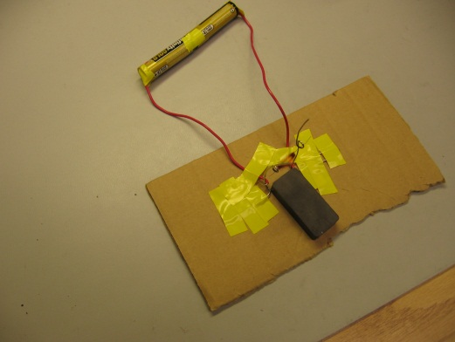

1. Disconnect the battery and replace them with an ammeter. Place the permanent magnet on the cardboard with one pole pointing up towards the loop. Notice that when the loop is stationary, the ammeter reads no current. Now try manually rotating the loop by pushing down on it. You should see that the measured current changes in time. This behavior will be explained in class #3 on generators. Finally, hold the loop fixed and move the permanent magnet towards and away from the loop and notice that the measured current increases as you move the permanent magnet faster.

**Conceptual Review Questions**

1. For the motor, what happens when the magnet is far away from the red loop?
2. Can you identify the energy conversions in this project?
3. Can you name few appliances which use electric motor?

**Possible Answers**

1. The red loop will eventually stop rotating if the magnet is far enough away.
2. The motor converts electrical energy from the battery into mechanical energy in the spinning loop. The generator converts the mechanical energy of you moving the permanent magnet towards and away from the red loop into electrical energy as current flows.
3. A washing machine, dryer, ceiling fan, vacuum cleaner, car, and garage door opener all use an electric motor.

**Class #3 - Generators**

**When current is flowing through a wire, it creates a magnetic field. Can we instead use a magnetic field to create a current?**

Yes. But, we need a changing magnetic field. When the magnetic field that enters a loop of wire changes, there is a current that is induced in the wire that tries to oppose this change. This current is created in the closed loop of wire without a connection to any battery. Current only flows when the loop of wire is closed because the moving electrons cannot pile up. If the loop is broken then there will not be any current.

**So, can we use the motion of a spinning loop to generate electricity?**

Yes. At the end of project #2, you manually rotated your loop of wire in a magnetic field and generated a current in the loop of wire. The amount of current that you generate increases proportionally to the number of winding turns of the wire. The generated current also increases in proportion to how fast you spin the loop and also in proportion to the area of the loop. Notice that since all motion is relative, we could instead have a stationary loop of wire and move the surrounding magnetic field. These two cases were the last experiments in project #2.

**What is a generator?**

A generator is the exact opposite of a motor. **A generator is a device that transforms mechanical energy into electrical energy.** We saw previously that to generate current, we needed relative motion between the loop and the permanent magnet. So, in this class we will mechanically change the magnetic field to create electricity and thereby make a generator.

**Project #3 - Building a generator**

**Objective:** To understand how a changing magnetic field can create an electrical current.

**Special Instructions:** The instructor may want to prepare this setup in advance and allow students to explore the results. This project uses inexpensive items to demonstrate how a generator works and the energy conversions during operation. Time permitting, each team can prepare its own setup.

**Parts needed for the class:**

1. cardboard
2. ruler and scissors
3. tape or glue
4. long nail or screwdriver
5. magnet (1x2x5cm [ceramic](http://amasci.com/coilgen/rsmagnet.html) magnet: [Radio Shack #64-1877](http://www.radioshack.com/product/index.jsp?productId=2102689))
6. #30 Magnet wire 200ft, [Radio Shack 278-1345](http://www.radioshack.com/product/index.jsp?productId=2036277)
7. Digital multimeter (suggested: Equus 3320 Auto-Ranging Digital Multimeter)
8. Light emitting diode (LED) (suggested: Radio Shack #276-022 green or #276-209 red)

**Project setup (see video #4)**

1. On the cardboard, cut and draw the diagrams with dimensions shown in the photos.

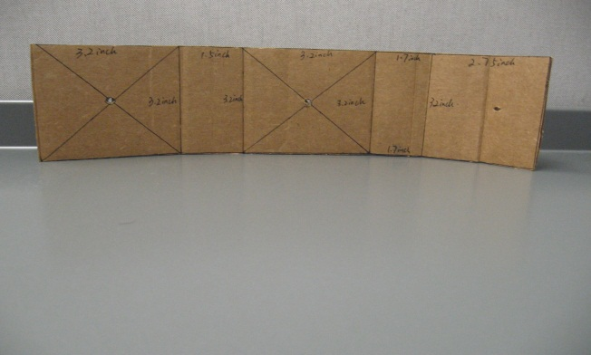

1. Next, prepare a box and create a hole in the center of its side with a screwdriver.

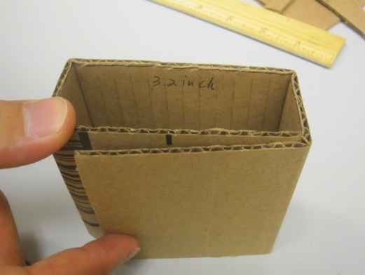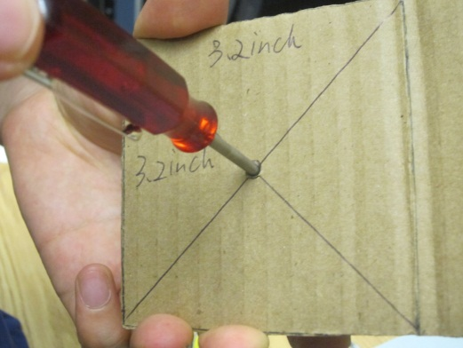

1. Open the box and keep the screwdriver in the hole. Attach magnets on both sides of the screwdriver using spare pieces of cardboard to keep the magnets separated. **Warning: The magnets are strong and can snap together easily. Be careful with your fingers.**

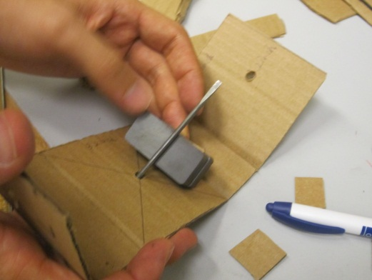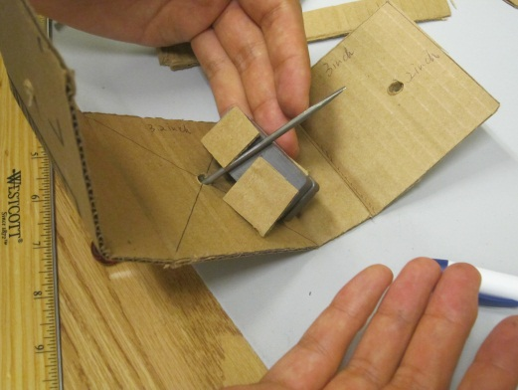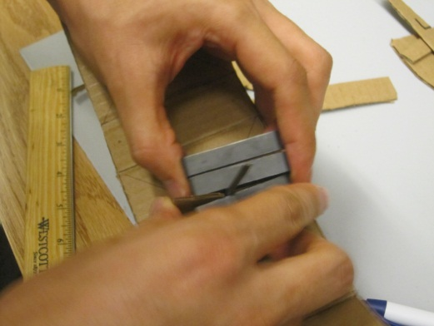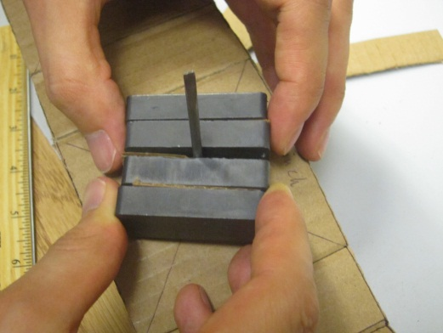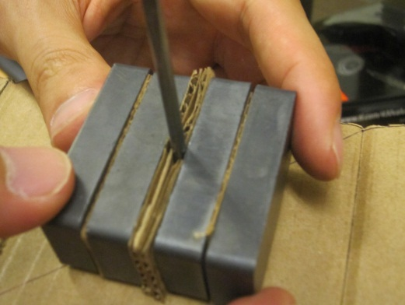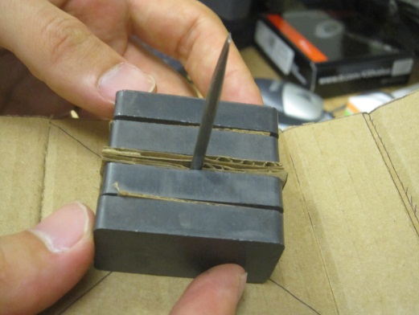

1. Tape the magnet together and secure it around the screwdriver and close the box.

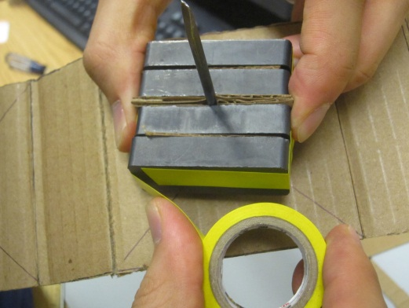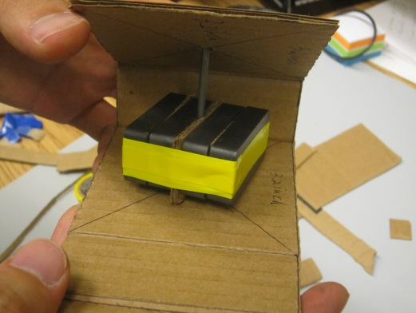

1. Start winding the magnetic wire around the box. Allow about 10” of loose wire on each end for later connection to an LED. Make approximately 200-400 loops of wire around the box. The loops should go on both sides of the screwdriver and need to continue in the same direction.

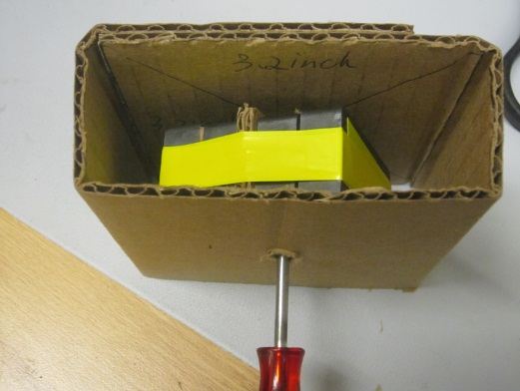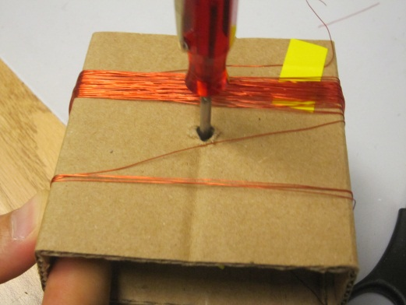

1. Connect the loose ends to the digital multimeter and measure the voltage generated when you spin the screwdriver. This will cause the magnets inside to spin and change the magnetic field that is passing through the loops of wire and generates electricity! Finally, replace the multimeter with an LED and spin the screwdriver. You should observe that there is light from the LED without a connection to any battery or external power source.

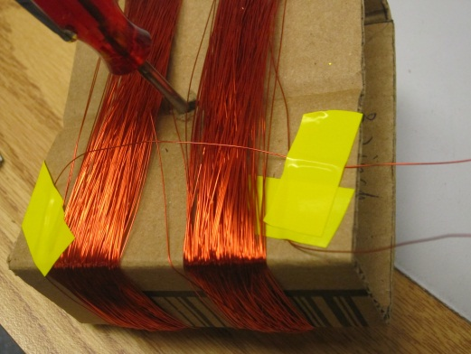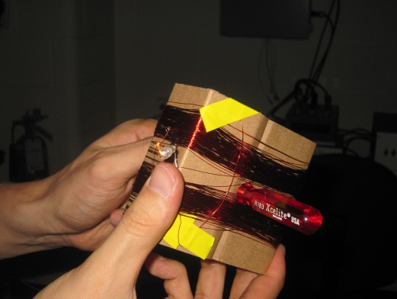

**Conceptual Review Questions**

1. Can you identify the energy conversions in this project?
2. Can you explain the energy conversions in a wind power plant that has spinning blades?

**Possible Answers**

1. The generator converts the mechanical energy of you spinning the permanent magnet into electrical energy as the current flows. This electrical energy is converted into light energy when the LED lights up.
2. Wind power plants convert wind energy into the mechanical energy of the spinning blades. A generator then converts this mechanical energy into electricity.

**Class #4 - Solar Energy**

**Can we convert sunlight into electrical energy?**

Yes. A solar panel absorbs solar energy from sunlight and converts it into electrical energy. Solar is a renewable energy source. **A renewable energy source gets its energy from a natural resource** such as sunlight, wind, rain, ocean waves, or geothermal heat. **A photovoltaic cell is a type of solar cell that directly converts solar energy into an electrical current.** There are other ways to convert solar energy into electrical energy. For example, **in a solar thermal generator, sunlight is focused with lenses or mirrors and the heat is used to convert water into steam that then drives a steam turbine generator**. The steam turbine converts energy from the steam into rotational kinetic energy and this rotational energy can be used to generate electricity using the generator concepts of class #3.

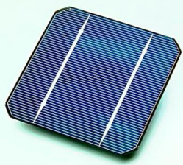

Figure 9 A photovoltaic cell

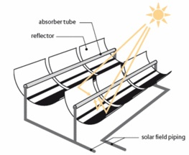 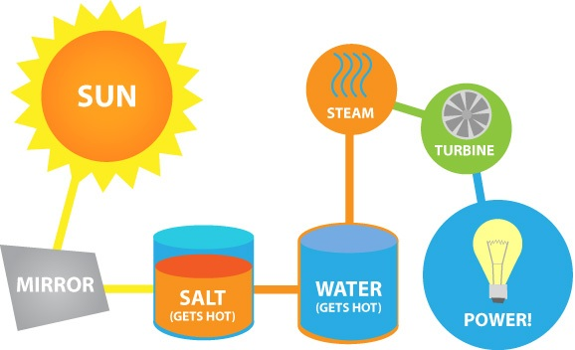

Figure 10 A solar thermal generator. Heat from the sun produces steam which turns a turbine and produces electricity. Salt tanks store heat for longer time periods and provide additional power even when the sun goes down.

**Series and parallel connections revisited**

The differences between a series and a parallel connection are very important. As a review, circuit elements are connected one after the other in a series connection. Since electrons must flow from one element to the next and not pile up inside the circuit, the current flowing through any element in a series connection is the same. On the other hand, in a parallel connection, the left ends of all circuit elements are connected together and the right ends of all elements are connected together. Thus, each electron has a choice as to which element to flow through and so the current through each element can be different. However, the voltage, which represents the height of the hill from the left side to the right side, must be the same for each element in the parallel connection because they’re all connected together on each side.

**Project#4 - Capturing light energy to spin a tiny motor**

**Objective:** To understand the working principles of a solar panel and the differences between a series and a parallel connection.

**Parts needed for the class:**

1. 2 solar panels (suggested: 2 of Radio Shack 0.5W Solar Panel 9V- Model: P0590 Catalog #: 277-047 OR 2 of 1 Amp Silicon Solar Panel with Flexible Ribbon Leads Attached - G18219)
2. Digital multimeter (suggested: Equus 3320 Auto-Ranging Digital Multimeter)
3. Spool of 18 AWG stranded wire, banana/alligator connectors, wire strippers/cutters
4. Optional: miniature lamp, 1.5V 25mA Radio Shack #[272-1139](http://www.radioshack.com/product/index.jsp?productId=2102813)
5. Optional: flexible desk lamp (suggested: 60 W)

**Project setup (see video #5)**

1. The front and back side of a single solar panel are shown below. The front looks dark and the back has a positive (+) sign to match with the + sign used when making a battery connection. The red wire is for the + side connection and the black wire is for the negative (-) side.

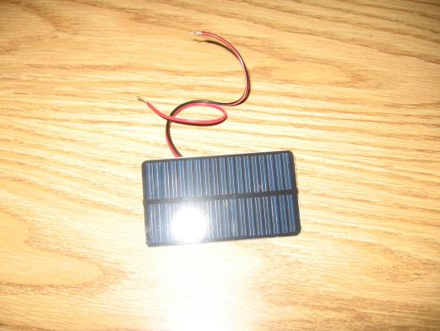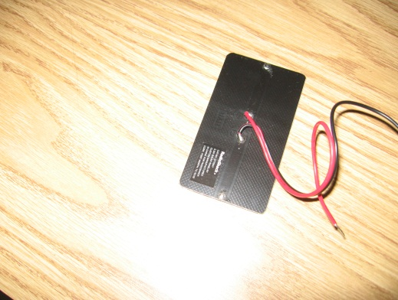

1. Plug the solar panel leads into the multimeter with the red wire connected to the positive input and black wire to the ground input. Set the multimeter to measure voltage and then current. It is important to do this project in natural sunlight. Clouds will affect your results so it is best to do this on a sunny day. We observed a voltage of 10.06 V and a current of 50.2 mA from a single solar panel. Your results will vary.

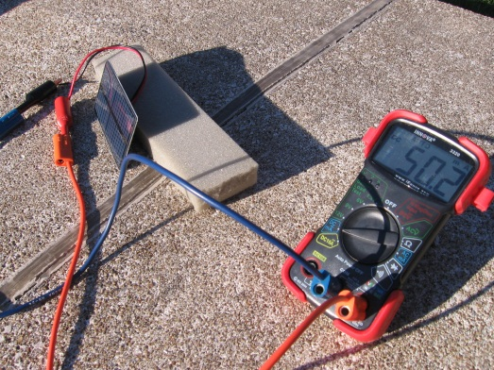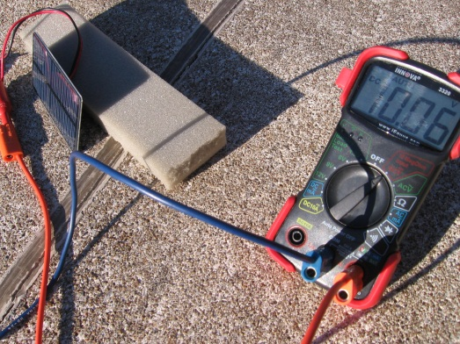

1. **The measured voltage of 10.06 V is known as the open circuit voltage and represents the maximum amount of energy available to do work.** When we view the solar panel like a battery source, the open circuit voltage represents the voltage rating of the battery. In other words, we have slightly more energy than a typical 9V battery. **The measured current of 50.2 mA is known as the short circuit current and represents the maximum current that the solar panel can supply.** Again, thinking of the solar panel like a battery, the short circuit current represents the amount of current that would flow if you were to connect a wire directly between the positive to the negative terminals. Warning: do not try to intentionally short out a battery since it will get extremely hot extremely quickly. For example, a typical 9V battery or even a 1.5V AA battery can supply about 5-10 A of current when short circuited. The current from our solar panel is very low in comparison to a single 9V or AA battery. This is because the solar conversion efficiency is low and the panel area is small. We will see later that we can connect multiple solar panels together to increase this current. Try moving around your solar panel setup in the sunlight so that the open circuit voltage reaches at least 9 V and the short circuit current reaches at least 50 mA, which are approximately close to the maximum ratings of a single panel.
2. The single solar panel you are using actually contains many solar cells internally connected both in series and in parallel inside the panel. The series connections are there to increase the output voltage from about 0.7V from a single cell to 10 V for the full panel while the parallel connections are there to increase the output current by increasing the collection area.
3. Clouds reduce the amount of sunlight reaching the solar panel. Simulate a cloud by putting a thick piece of paper in front of the solar panel and cover half portion of the solar panel. We observed 9.38 V for the voltage and 3.06 mA for the current. These values will change based on how effectively we block the sunlight and how thick the paper is. Since both halves of the solar panel are connected in series internally, blocking one half is almost equivalent to completely breaking the circuit from the covered portion side. This creates a great reduction in the short circuit current but the voltage represents the open circuit voltage and thus it approximately remains the same as that of the previous single panel case.

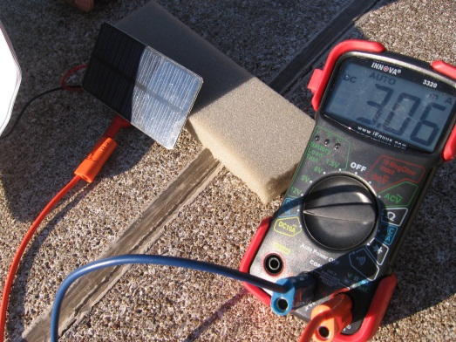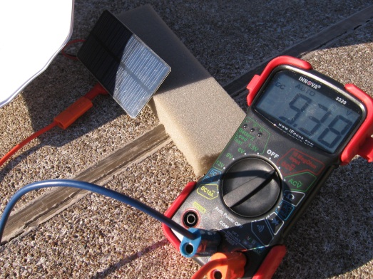

1. What happens when we can cover the lower half of the solar panel with thick paper? We observe open circuit voltage of 9.93 V and short circuit current of 20.2 mA. This is because the upper and lower halves of the solar panel are connected in parallel. Blocking the lower half will still allow us to get current and voltage from the upper half. But this time we are using only half of the area of the panel and thus we get current which is half in value in comparison to the unblocked case.

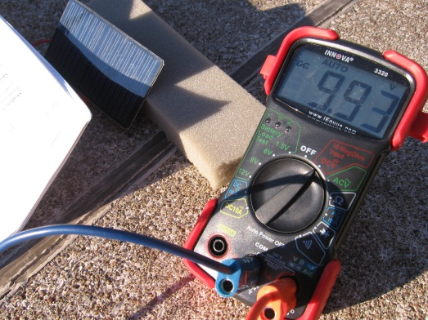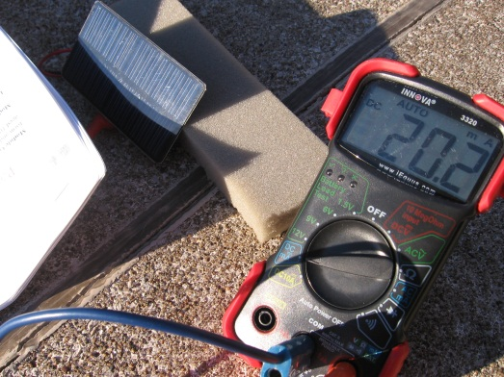

1. What happens when we connect two solar panels in series? In series mode, we connect elements like links in a chain: the negative end of the digital multimeter is connected to the negative end of the first solar panel, the positive end of the first solar panel is connected to the negative end of the second solar panel, the positive end of the second solar panel is connected to the positive end of the digital multimeter. We observed 20.7 V and 50.1 mA. With two solar panels connected in series, the maximum amount of energy available is approximately doubled. The hill that describes the voltage is now twice as high because we cascaded the two panels back to back. Notice that the current obtained is about the same as for a single panel because the current is the same everywhere in a series connection. The same charges flow through both solar panels. But, now we have doubled the maximum energy available to us.

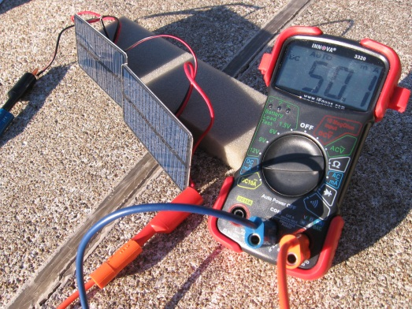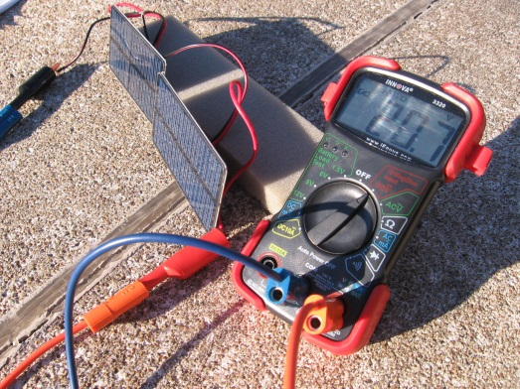

1. We can try putting thick paper and partially blocking the sunlight reaching just one of the solar panels. We observe a voltage of 19.8 V and a current of 2.80 mA. Notice that this current is about the same as for a single panel that is blocked. In series connection mode, the blocked solar panel determines the current. Thus, even when just one solar panel is partially blocked, we get almost no power. The physical explanation is a bit advanced. (For instructors’ information: in series, the current through both solar panels is the same. The unblocked solar panel is reverse biased and converts light energy to electrical energy while the blocked solar panel is slightly forward biased and is actually converting a very small amount of electrical energy back into light energy. The voltage necessary to forward bias the blocked panel is about 0.7V which is approximately equal to the difference in measured voltages for covered and uncovered.)

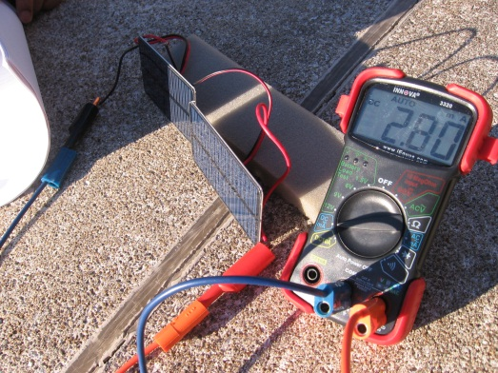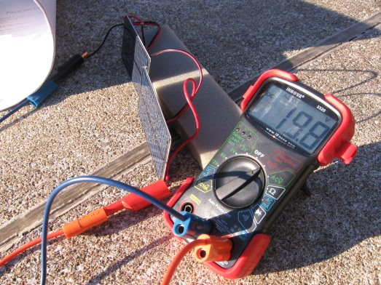

1. What happens when we cover the lower half of both the solar panels? We get 20 V and 22.6 mA. The explanation is same as that for single solar panel case. Blocking the lower half reduces the light collection area by half so we get the current from the upper half which is half of the current from unblocked solar panels.

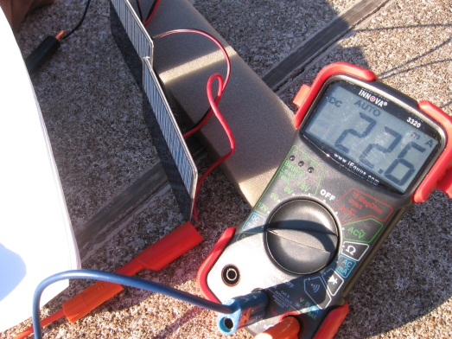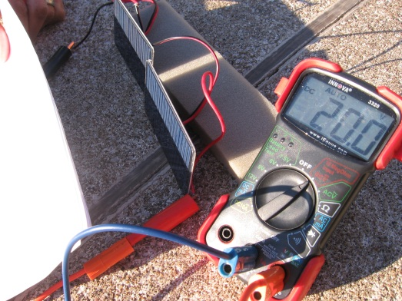

1. What happens when we completely disconnect one of the solar panels? We don’t get any voltage or any current at all because our series connection is broken. The circuit does not form a closed path for electrons to move around. This is almost what happens when we shade one of the solar panels.
2. What happens when we connect the two solar panels in parallel instead? In parallel mode, we connect positive ends (+ sign side) of each solar panel and of the multimeter together. We also connect the negative ends of each solar panel and of the multimeter. Remember that in a parallel connection, there are two paths for electrons to flow and that the voltage across each element is the same. Thus, with two solar panels each capturing light, we will get approximately double the short circuit current of a single solar panel but the open circuit voltage will remain around 10 V. We observed a 10.52 V and 97 mA. These values change depending on natural clouds in the sky.

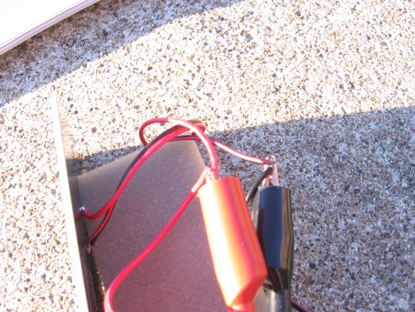

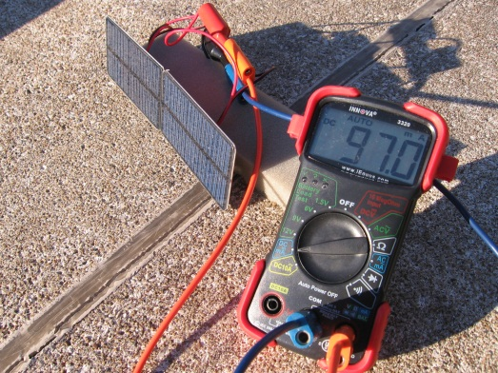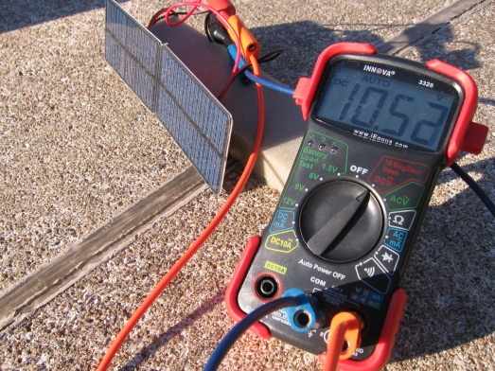

1. What happens when we shade or completely disconnect one of the solar panels? Now, we can still get current from a single solar panel because both solar panels are linked in a way that even if one of them fails we can still get current from the other. When we blocked sunlight to one of the solar panels with a thick paper, we observed 10.18V and 51.1 mA. Again, these readings will change based on natural clouds. We got a voltage and current similar to the single solar panel. This is the main difference of connecting solar panels in parallel in comparison to connecting them in series.

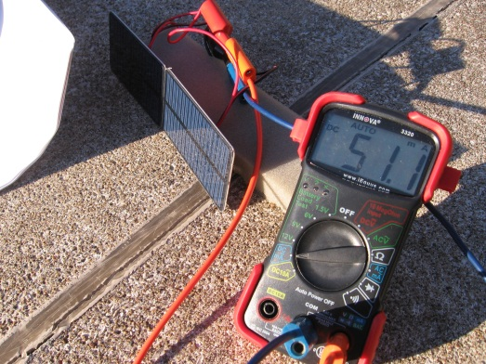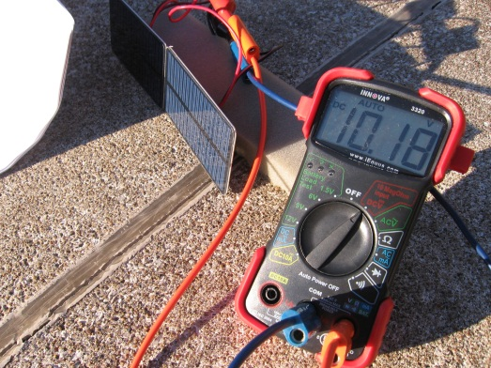

1. What happens when we cover the lower half of solar panels with a thick paper? Now we get 10.11 V and 48.3 mA. The results are similar as that of single solar panel case because the collection area is the same.

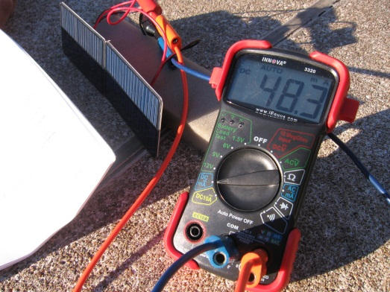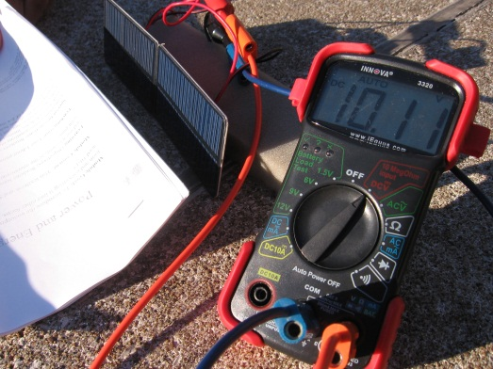

1. Now we can remove the multimeter and connect a motor to the unblocked solar panels and spin it using solar energy. The solar panels convert light energy to electricity and now we can use that energy by converting it into the mechanical energy of the rotating motor.

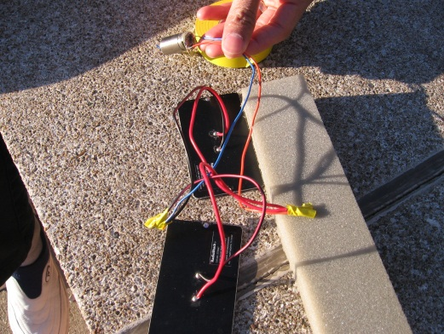

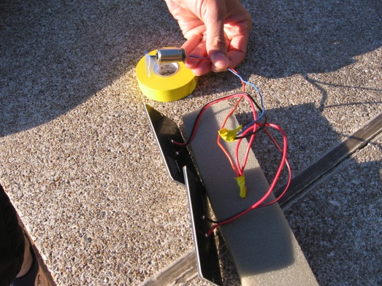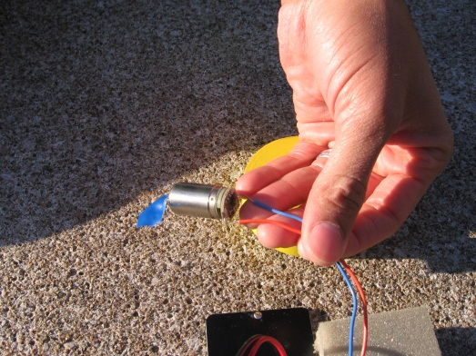

1. Let’s summarize the difference between series and parallel connections for solar cells. Suppose we have 10 solar cells. If we connect them in series, the open circuit voltage or maximum amount of energy available will be 10 times larger than that of a single cell, but the current will be the same as a single cell. If a single cell malfunctions, we will get almost zero current from our system. The solar energy does not generate any electricity for us to use. For 10 solar cells connected in parallel, the open circuit voltage will be the same as a single cell, but the current will be 10 times larger. If a single cell malfunctions, we will get 9 times the current from a single cell. There are many tradeoffs when designing a solar panel with multiple cells because the panel needs to not only supply large open circuit voltages and large short circuit currents, but also perform well when one or more cells malfunction or are in the shade of a cloud.
2. Let’s go back inside. Place the panel in ambient room light. We got 3.19 V and 0.10 mA. Sunlight delivers significantly more energy to the solar panel than the ambient room light.

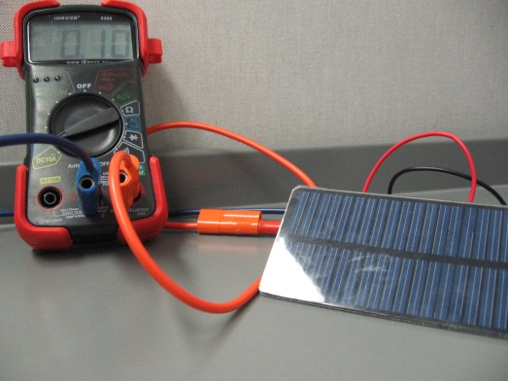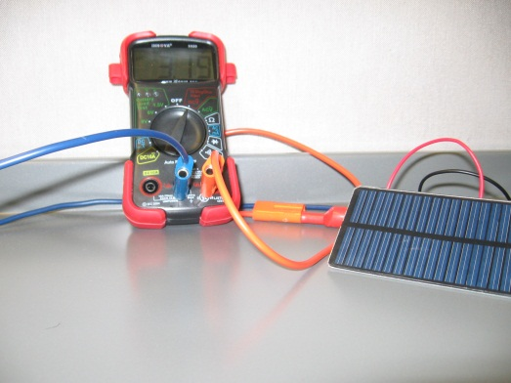

**Conceptual Review Questions**

1. Can you identify the energy conversions in this project?
2. Can you think of some applications of solar cells?

**Possible Answers**

1. The photovoltaic cell converts solar energy into electrical energy.
2. In some states, home owners have installed solar panels on the roofs of their houses to generate electricity. At some times of the day, the house can generate more electricity than it consumes. In some states, the home owner can then sell this extra electricity back to the electric company. Also, there are many water pumps that use solar panels for watering farms or for domestic use. This water pumping system is made up of an array of photovoltaic cells that powers an electric motor, which drives a pump. The water is pumped from the ground into a storage tank.

**References for images:**

1. <http://www.allaboutcircuits.com/vol_1/chpt_1/2.html>
2. <http://www.thetech.org/exhibits/online/topics/12c_flash.html>
3. <http://www.fi.edu/htlc/teachers/lettieri/classroomexperimentsandactivities.html>
4. <http://chrischung-sph3u.blogspot.com/2010/09/blog-1-notes-on-current-electricity.html>
5. <http://barbaraeportfolio.blogspot.com/>
6. <http://www.pearsonschoolsandfecolleges.co.uk/Secondary/Science/14-16forEdexcel/EdexcelIGCSEBiologyChemistryPhysics/Samples/PhysicsRevisionGuide/PhysicsRevisionGuideChapter22.pdf>
7. <http://www.school-for-champions.com/science/electromagnetism.htm>
8. <http://www.khadley.com/courses/lectures_ph102/lecture5_28_10.aspx>
9. <http://oscience.info/physics/magnetism/>
10. <http://www.good.is/posts/the-other-solar/>
11. <http://www.renewables-made-in-germany.com/en/start/solarenergie/solarthermische-kraftwerke.html>
12. <http://www.energyquest.ca.gov/projects/open-short-circuit.html>
13. <http://en.wikipedia.org/wiki/Solar_cell>

**Index of Key Terms**

**ammeter**, 4

**Amps (A)**, 4

**current**, 4

**electricity**, 2

**electromagnet**, 5

**energy**, 2

**generator**, 16

**magnetic field**, 4

**milli-Amps (mA)**, 4

**motor**, 10

**multimeter**, 4

**Ohm’s law**, 8

**Ohms ()**, 2

**open circuit voltage**, 23

**parallel**, 7

**photovoltaic**, 21

**renewable energy**, 21

**resistance**, 2

**series**, 7

**short circuit current**, 23

**solar thermal generator**, 21

**voltage**, 4

**Volts (V)**, 5